Sankeerth Aare
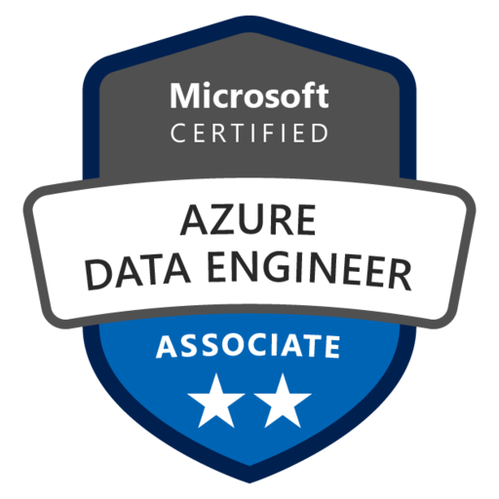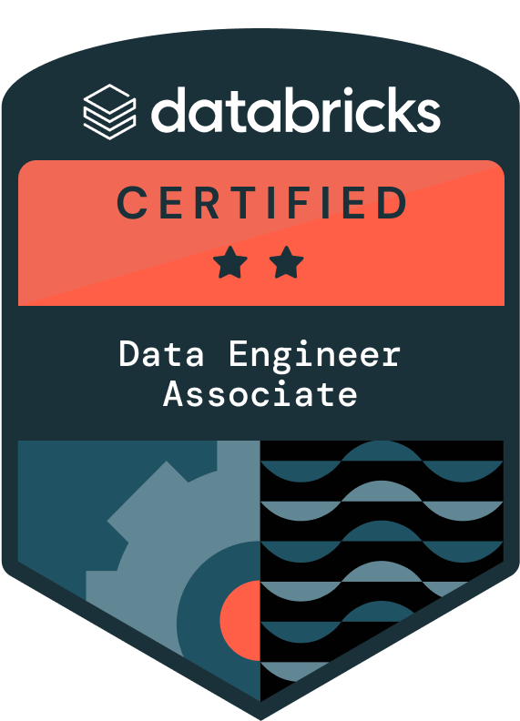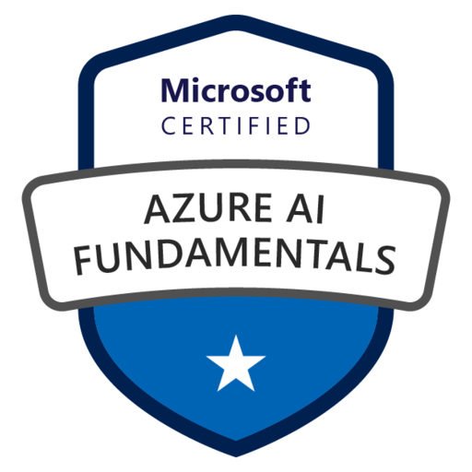
Senior Azure Data Engineer

Mobile: +1(469) 214-5606
Email: sankeerthaare10@gmail.com
LinkedIn: http://www.linkedin.com/in/sankeerth-aare-7b5431220
SUMMARY
- 10+ years of experience architecting and implementing complex data solutions, including cloud platforms, data warehousing (OLAP), relational database systems (OLTP), NoSQL data stores, ETL/ELT pipelines, and real-time data flow processing, utilizing advanced techniques like data governance, security, automation, data modeling, and performance optimization.
- Designed and deployed scalable Change Data Capture pipelines using Azure Data Factory, Azure Databricks, and Azure Synapse Analytics, integrating Teradata (OLTP) and other sources for unified big data analytics.
- Designed secure, enterprise-grade Azure data solutions with cost-effective Blob Storage, Data Lake Gen2, Event Hubs (real-time ingestion), Stream Analytics (processing), Logic Apps (workflow), Functions (event-driven), Key Vault (secrets), Power BI (reporting), and Python scripts (custom validation).
- Implemented secure and scalable data processing in Azure Data Factory by leveraging Python-based encryption, Key Vault integration, and metadata-driven transformation with Azure Blob Storage and Azure Data Lake Gen2 for optimized data movement.
- Designed scalable Azure Data Factory pipelines with automated schema drift handling, leveraging Python-based dynamic mapping and parameterized datasets to enable flexible, efficient data ingestion from diverse sources.
- Proactively monitored Synapse Analytics with Monitor, Application Insights, and Query Performance Insights, resolving bottlenecks to improve data access and reduce query time, harnessing Azure Databricks for advanced transformations.
- Used Azure Databricks with Synapse Analytics for enterprise-grade transformations and skilled in building robust data solutions using Python for advanced engineering workflows.
- Handled large-scale data volumes via distributed processing and optimized resource use in Databricks clusters, employing PySpark to accelerate transformations.
- Extensively worked on Spark transformations (PySpark) for data cleansing, shaping, and processing in Azure Databricks, leveraging ETL frameworks and cloud-native pipelines.
- Fine-tuned Spark(PySpark) with Adaptive Query Execution, Catalyst optimizer, and Tungsten Execution Engine to maximize performance and scalability. Automated data classification and labeling with Azure Purview for consistent protection and compliance.
- Adopted SSIS packages for data flow from legacy systems to Data Lake Storage Gen2. Used Python with SSIS for advanced data manipulation. Leveraged Azure Cosmos DB (NoSQL) for globally distributed data and Teradata (OLTP) for structured needs.
- Established data governance with Azure Data Catalog and Polybase for lineage, metadata management, security, and compliance. Employed Azure AD and IAM (RBAC) for secure access control and governance.
- Used Azure Monitor for performance monitoring, real-time log analysis, and pipeline troubleshooting, ensuring optimal resource utilization.
- Leveraged OLTP/OLAP to create Snowflake schemas in Synapse for powerful enterprise analytics and big data processing (Hadoop, HDFS, MapReduce, Hive).
- Enabled real-time operations and data-driven insights using Azure Stream Analytics integrated with Snowflake under Azure Purview governance.
- Developed and optimized data integration pipelines using Azure DevOps YAML pipelines, ensuring automated testing, deployment, and version control of ADF, Synapse, and Databricks components.
- Implemented Infrastructure-as-Code (IaC) with Terraform in Azure DevOps, enabling automated provisioning of Azure Data Factory, Synapse Analytics, and related resources.
- Integrated Azure DevOps CI/CD pipelines for automated deployment of Azure Data Factory (ADF) pipelines, Synapse workspaces, and infrastructure provisioning with Terraform.
- Proficient in Python (Pandas, NumPy), SQL, Scala, PySpark, and PowerShell for data manipulation and scripting, and adept with Azure Databricks for big data orchestration.
- Implemented ETL/ELT with Sqoop, Flume, Azure Data Factory, and PySpark for reliable data integration, secured by Key Vault, plus Python scripts for complex transformations.
- Extensively worked with Apache Spark (1.0–3.5) and Kafka for high-throughput, fault-tolerant processing of large datasets.
- Used PySpark, Spark SQL, and Scala for complex transformations and analytics, leveraging Spark’s in-memory parallel execution on Azure Data Lake Storage and HDFS.
- Developed scalable dimensional data models in Azure Synapse with MDM and Azure SQL for data access and Power BI analysis.
- Developed highly interactive and scalable Power BI dashboards, integrating with Azure SQL Database and Synapse Analytics to visualize real-time business KPIs, operational metrics, and financial trends.
- Integrated Power BI Embedded APIs with Azure SQL Database to enable self-service analytics and embedded reporting solutions, facilitating data-driven decision-making across enterprise teams.
- Implemented Type 2 SCD via Azure Data Factory for time-varying data in ADLS-backed dimensional tables with data governance. Extensively worked on data formats (Avro, JSON, CSV, Parquet, ORC, XML), optimizing configurations across the lifecycle.
- Skilled in multiple programming languages (UNIX/Linux) for data manipulation and automation. Followed SDLC methodologies, ensuring quality, consistency, and best practices, including thorough PySpark code reviews.
- Developed and maintained documentation (technical specifications, data dictionaries, pipeline workflows, governance procedures) using Confluence and SharePoint to ensure knowledge transfer, operational continuity, and cross-functional collaboration.
- Led cross-functional collaboration between Salesforce Developers, SAP specialists, Data Analysts, BI Developers, Business Analysts, Data Scientists, and Data Modelers to design and implement enterprise-wide ETL pipelines and data integration architecture.
- Utilized Jira for Agile (Scrum, Kanban) and Waterfall implementation, collaborating with cross-functional teams through Sprint planning, Stand-ups, Retrospectives, and PI planning to deliver data-driven solutions that met business requirements.
SKILLS
Cloud Technologies: Azure Data Factory (ADF), Azure Data Lake Storage (ADLS), Azure Synapse Analytics (SQL Data Warehouse), Azure SQL Database, Azure Cosmos DB(NoSQL), Azure Key Vault, Azure Databricks, Azure Stream Analytics, Azure Event Hubs, Azure Logic Apps, Azure Functions, Azure Data Catalog, Azure Monitor, Azure Purview, Azure Storage Explorer.
Databases: Oracle, MySQL, SQL Server(OLTP), Teradata, Cosmos DB(NoSQL), Netezza, Teradata, Snowflake(Snow SQL),Mango DB, Azure SQL, Cassandra.
Programming Languages: Python, PySpark, Shell script, SQL(T-SQL,PL/SQL,SQL Server), Java, Scala
Big Data Technologies: Cloudera, Hortonworks.
Big Data Tools: Spark, Sqoop, Hive, Oozie, Zookeeper, Kafka, Flume, HDFS, MapReduce, YARN, Airflow, Nifi, PySpark, Hadoop.
ETL Tools: Informatica, SSIS
File Formats: Avro, Parquet, Json, CSV, XML.
CI/CD Tools: Terraform, Apache airflow, Jenkins, Azure DevOps, Kubernetes, Docker, Ansible.
Version Control: GIT, GitHub, Bitbucket
Operating Systems: Windows 10/7/XP/2000/NT/98/95, UNIX, LINUX, OS
Reporting Tools: Power BI, Tableau, Cognos.
Data Modeling: Dimensional modeling, OLTP schema design, Erwin

EDUCATION
- Masters(Computer Science) – University of Memphis,2013
- Bachelors(Computer Science) – Guru Nanak Institutions Technical Campus,2011
CERTIFICATIONS
- Microsoft Certified Azure Data Engineer Associate - DP 203
- Microsoft Certified Azure Fundamentals - AI 900
- Databricks Certified Data Engineer Associate
EXPERIENCE
Client: Optum November 2022 to Current
Senior Azure Data Engineer Los Angeles, California

- Architected and implemented a HIPAA-compliant healthcare data processing platform using Azure Data Factory, Databricks, and PySpark, streamlining insurance claims processing from HL7, FHIR, and X12 formats and achieving faster transaction processing while enhancing data accessibility for business intelligence reporting.
- Developed and maintained end-to-end ETL pipeline operations and worked with big data sets using Azure Data Factory, leveraging PySpark frameworks to enhance processing speed.
- Implemented Python-based transformations in Azure Databricks for parsing and validating HL7, FHIR, and X12 (.edi, .txt) insurance claim data, ensuring compliance with HIPAA regulations.
- Built a scalable ingestion framework in Azure Data Factory Data Flow to process real-time medical transactions and insurance claims, optimizing processing time by using ADF Copy Activity, Lookup Activity, and Data Flow transformations.
- Designed and implemented data pipelines with Azure Data Lake Storage Gen2 (ADLS) for scalable and secure data landing, and Azure Databricks (Apache Spark) with Spark SQL and Python for high-performance big data transformation.
- Extensively worked on Azure Data Factory (ADF) pipelines and linked services to ingest data from internal sources and HTTPS/RESTful APIs for extracting data from external sources, enabling fast and efficient data ingestion into Azure Data Lake Storage(ADLS)Gen2.
- Leveraged Azure Databricks (PySpark, SQL) to process and transform large datasets containing medical coding standards (ICD-10, CPT Codes, NPI numbers), improving claims accuracy and fraud detection.
- Integrated Azure Blob Storage with Azure Data Factory pipelines to securely store structured and semi-structured healthcare data (CSV, JSON, XML, PDF) from Electronic Health Records (EHR) and insurance claims (HIPAA 837, 835).
- Leveraged Kryo serialization within Spark, as part of Spark performance tuning, for efficient data exchange between compute nodes, reducing network overhead and boosting processing speed within Azure Synapse Analytics.
- Optimized partition strategies and distribution in Azure Synapse Analytics tables, employing Round Robin distribution for high join cardinality and hash distribution for frequently joined tables, resulting in improved join performance.
- Configured clustered columnstore indexes for frequently accessed columns within Azure Synapse Analytics tables, optimized for OLAP workloads, minimizing disk I/O and enhancing query execution speed.
- Implemented compression formats like Parquet and ORC within Azure Synapse Analytics tables, reducing data storage footprint and accelerating data scans.
- Extensively worked on Python-based vectorized UDFs, broadcast variables, and parallel operations for faster data processing and leveraging Spark's distributed nature and implemented IaC with Terraform for resource provisioning and configuration of Azure services.
- Monitored performance with Spark UI, Ganglia, and Azure Databricks Profiler to identify bottlenecks and optimize resource allocation.
- Leveraged Spark SQL, DataFrames, and Python libraries (Pandas, NumPy) within Azure Databricks for data transformations like filtering, joining, aggregating, and grouping, for efficient data preparation and analysis.
- Optimized Spark configurations and worked on Adaptive Query Execution for better resource utilization and query plan optimization.
- Built robust data platforms leveraging Azure Data Factory , Lakehouse architecture, and Delta Lake for efficient data ingestion, transformation, and serving for various reporting/analytical needs.
- Leveraged Azure Purview to create a unified data landscape, streamlining discovery, lineage tracking, and access control, boosting data findability and compliance and Azure Polybase for joining tables from diverse sources.
- Automated data classification and labeling across diverse sources using Azure Purview while promoting data discovery, lineage tracking, and governance best practices through Azure Data Catalog, ensuring consistent data protection and compliance.
- Designed data integration pipelines with Azure Blob Storage-integrated Informatica IICS, streamlining acquisition from databases, APIs, and cloud apps while ensuring raw data staging in cost-effective Azure Blob Storage before transformation.
- Leveraged Spark SQL, DataFrames and Python libraries (Pandas, NumPy) within Azure Databricks for data transformation like filtering, joining, aggregating, and grouping, enabling efficient data preparation(ETL processes).
- Developed SQL/PL-SQL queries for data warehousing using DDL, DML, and schema objects (indexes, triggers, views, stored procedures, functions, packages), collaborating with teams to design ETL pipelines that ensure data integrity and precise transformations.
- Developed custom activities using Azure Functions, Azure Databricks, PowerShell and python scripts, Azure Logic Apps to perform data transformations, data cleaning, data validation, automating workflows and orchestrating data movement(data wrangling).
- Implemented Parquet format with partitioning and Delta Cache for efficient data access, filtering and reducing recomputation(Spark performance tuning)
- Leveraged Azure Purview to create a unified data landscape, streamlining data discovery, lineage tracking, access control, boosting data governance compliance and used PolyBase for joining tables from diverse sources.
- Automated data classification and labeling across diverse sources with Azure Purview, ensuring consistent data protection (sensitive data classification).Promoted data discovery, lineage tracking and governance best practices through Azure Data Catalog.
- Extensively worked on vectorized UDFs, broadcast variables, and parallel operations for faster data processing using Spark’s distributed nature and implemented IaC with Terraform for resource provisioning of Azure services.
- Monitored performance with Spark UI, Ganglia, and Databricks Profiler (Azure Monitor) to identify bottlenecks and optimize resource allocation.
- Established robust data governance with Azure Active Directory (Azure AD) and RBAC for secure access control and user management.
- Designed and implemented Azure-based Lakehouse architecture (Bronze/Silver/Gold) utilizing Azure Data Factory, DataOps methodology, Blob Storage and Delta Lake, enabling seamless integration of structured/semi-structured data via Databricks.
- Implemented zero copy cloning within Snowflake (leveraging Time Travel) to achieve rapid data replication minimizing downtime and data loss.
- Demonstrated proficiency in diverse file formats (Avro, JSON, CSV, Parquet, ORC, XML) for structured and semi-structured data across data management stages, tailoring formats for specific needs.
- Demonstrated understanding of OLTP and OLAP data models, including dimensional modeling, designing Snowflake schemas optimized for both transactional processing and analytical workloads.
- Leveraged Snowflake's time travel functionality for historical data auditing/compliance and automated data processing tasks via Azure CLI to optimize Snowflake administration.
- Designed infrastructure using ARM templates deployed through Azure DevOps, ensuring declarative, repeatable provisioning while managing schema evolution in Delta Lake tables to handle structural changes without data loss.
- Implemented batch/streaming pipelines for Delta Lake ingestion and performed complex transformations using SQL/Python APIs, coupled with Slowly Changing Dimensions (SCDs) to maintain historical data integrity.
- Delivered refined data to Azure Synapse Analytics for advanced analysis and storage, ensuring efficient access and insights.
- Boosted cloud storage management efficiency by leveraging Azure Storage Explorer for intuitive browsing, data manipulation, and transfers across various Azure storage services (Blob, File, Queue, Table), streamlining data access and collaboration.
- Established comprehensive data governance across diverse sources via Azure Purview, ensuring data lineage, access control, and compliance while simplifying data discovery and trust.
- Orchestrated Jenkins-driven CI/CD workflows to automate data pipeline updates, reducing manual effort. Developed Shell/Unix scripts to automate big data processing and system administration tasks.
- Executed software engineering phases (requirements analysis, design, code, testing) for data pipeline solutions, using GitHub for version control and Atlassian suite (JIRA/Confluence) to manage/report on Development, QA, and Partner validation workflows.
- Experience in full breadth of Agile methodologies, from daily stand-ups to internationally coordinated PI Planning, for large-scale data initiatives.

Environment: Azure Databricks, Azure Data Factory, Azure Logic Apps, Azure Data Lake Storage Gen2 (ADLS), Azure Functions, MS SQL Server, ETL/ELT, Spark SQL, Azure AD, Azure Key Vault, Terraform, Azure Data Catalog, Azure Synapse Analytics, Azure Purview, Azure Storage Explorer, Kryo serialization, Ganglia, Lakehouse architecture, Informatica IICS, DataOps methodology, Snowflake, SQL, PL/SQL, RESTful API, HTTPS, Python, Scala, PySpark, Agile methodology, GitHub, JIRA, Jenkins, Power BI.

Client: Master Card January 2019 to October 2022
Azure Data Engineer New York Metropolitan Area, New York

- Implemented secure hybrid cloud architecture for real-time global payment processing, migrating data from legacy systems (Oracle, Teradata, Netezza) to Azure using Data Factory and Synapse Analytics. Deployed Azure Event Hubs and Stream Analytics for real-time transaction monitoring with advanced fraud detection while ensuring PCI DSS compliance for financial data.
- Leveraged Azure Data Factory (ADF) for secure and efficient data extraction from diverse on-premises and cloud sources using dedicated connectors and ODBC/JDBC drivers.
- Transformed and integrated data using Azure Synapse Analytics, a serverless data warehouse, leveraging its serverless architecture for scalability and cost-effectiveness.
- Ensured data consistency in Azure Synapse Analytics through schema standardization, quality checks, and error handling, while integrating diverse sources for a unified customer, account, and usage view.
- Designed and implemented ETL pipelines using Azure Data Factory and Databricks to process financial transaction data in SWIFT (.mt, .xml) and FIX (.fix, .xml) formats, ensuring compliance with ISO 20022 messaging standards.
- Built and optimized big data solutions on Azure Databricks to streamline KYC/AML data processing, ensuring adherence to PCI DSS security standards while integrating ACH & Wire Transfer transaction data.
- Worked on Migrating SQL database to Azure Data Lake Storage (ADLS), Azure Data Lake Analytics, Azure SQL Database, Azure Databricks, and Azure Synapse Analytics.
- Performed real-time data analysis on streaming data with Azure Stream Analytics, leveraging its complex event processing capabilities, and integrated with Azure Databricks for additional real-time transformations.
- Filtered data streams based on pre-defined business rules and conditions within Stream Analytics using its SQL-like query language, focusing on relevant information for immediate insights and action.
- Extensively worked on Stream Analytics built-in machine learning capabilities, leveraging machine learning models to detect fraudulent activities or unusual customer behavior patterns in real-time, enabling swift intervention.
- Aggregated and summarized data streams efficiently within Stream Analytics through real-time data transformations, reducing data volume and optimizing resource utilization for cost-effectiveness.
- Leveraged Azure Databricks Profiler to analyze job execution logs and optimize data partitioning strategies, resulting in an improvement in query performance for data warehousing operations.
- Extensively worked on Azure Data Lake Storage Gen2 (ADLS) for scalable and cost-effective raw data storage, partitioning based on source, date, and other relevant criteria for efficient management.
- Engineered SQL/PL-SQL solutions (DDL, DML, DQL, DCL) for schema management and data manipulation in Snowflake and Teradata, including CRUD operations in Snowflake SQL to streamline transactional workflows and ensure data integrity.
- Stored processed real-time data in Azure Cosmos DB, a globally distributed multi-model NoSQL database offering low-latency access and horizontal scalability for efficient storage and retrieval.
- Ensured secure and authorized data access to Event Hubs by using Azure Active Directory (AAD), a cloud-based identity and access management service, and restricting access based on roles and permissions.
- Developed and implemented data pipelines using Delta Lake for efficient data storage, processing, and serving in data lakes, with supplementary processing using PySpark.
- Ensured data consistency and integrity within Azure Data Lake Storage (ADLS) data lakes with Delta Lake's ACID transactions, even for concurrent updates.
- Provisioned and managed various Azure resources using ARM templates, including Azure Virtual Machines, Azure Storage Accounts, Azure SQL Database and Azure App Service.
- Optimized Snowflake performance and storage efficiency by implementing zero-copy cloning for instant, cost-effective backups/archiving and materialized views to accelerate complex query response time.
- Implemented Azure Event Hubs (a scalable event ingestion service with auto-scaling capabilities) to handle surges in high-volume, real-time streaming data from diverse sources (network sensors, mobile, interactions, IoT devices).
- Leveraged Event Hubs partitioning (using partition keys) to efficiently distribute and process data streams based on source, type, or timestamp for optimized performance.
- Guaranteed data delivery even during failures with Event Hubs' built-in durability features, enabling fault-tolerant operations that prevent data loss and ensure information integrity.
- Architected and implemented real-time data pipelines using Apache Kafka and Azure Event Hubs, leveraging Kafka's high-throughput, fault-tolerant publish-subscribe model to efficiently and scalably ingest massive volumes of IoT data.
- Captured and streamed real-time data using Apache Kafka and Azure Event Hubs for efficient and scalable data movement.
- Enabled real-time visualization of network health, customer behavior trends, and fraud alerts through interactive Power BI dashboards, empowering stakeholders with immediate insights.
- Integrated Power BI with Azure Stream Analytics for seamless data flow and visualization, facilitating quick decision-making based on real-time data insights.
- Unearthed valuable insights from Telemetry and Timeseries data (IoT sources like Azure IoT Hub) using Jupyter Notebook for exploratory analysis and visualization, for enhanced performance and predictive maintenance capabilities.
- Worked on Microsoft Azure services like Azure HDInsight Clusters, Azure Blob Storage, Azure Data Factory and Azure Logic Apps and have done POC on Azure Databricks.
- Implemented complex Slowly Changing Dimensions (SCDs) as part of dimensional modeling for historical data integrity and accurate trend analysis/reporting.
- Created interactive Power BI dashboards and reports (DAX), effectively visualizing key metrics and communicating trends for improved decision-making.
- Implemented the integration of Azure Power Apps with Azure Data Factory(ADF) pipelines, forging a single, unified source of truth for critical business data, maximizing data consistency and accessibility across applications and reports.
- Implemented Delta Lake Optimize and Vacuum operations to maintain data quality and minimize query execution time for fraud detection analysis in Azure Databricks and integrated Python for custom performance metrics.
- Created interactive Power BI dashboards and reports (DAX), effectively visualizing key metrics, and communicating trends for improved decision-making.
- Loaded transformed data into curated datasets within Azure Synapse Analytics with partitioning and clustering based on expected query patterns for optimized data access and performance.
- Enabled interactive data exploration and ad-hoc analysis with Azure Synapse Analytics and integrated with Power BI for visually appealing reports and dashboards to share insights with stakeholders.
- Implemented robust data governance with Azure Active Directory (AAD) for secure access control and user management, and Azure Key Vault for sensitive data encryption.
- Deployed and optimized Python applications using Azure DevOps CI/CD pipelines, streamlining the deployment process and allowing the team to focus on development activities.
- Developed and maintained PowerShell scripts for automating data processing and system administration tasks on Windows-based systems. Employed Git as version control tools to maintain the code repository.
- Enhanced team efficiency by utilizing Atlassian tools like JIRA, Confluence for issue tracking, prioritization, and agile workflow management, streamlining project planning, documentation, and communication.

Environment: Azure Stream Analytics, Azure Event Hubs, Azure Databricks, Delta Lake, Databricks Profiler, User Defined Functions (UDF), Azure Data Factory, Azure Data Lake Storage Gen2 (ADLS), Azure Synapse Analytics, Azure SQL Database, Azure SQL Data Warehouse, Azure Logic Apps, Azure HDInsight, Terraform, Snowflake, Teradata, Netezza, Confluence, PySpark, Scala, Python, Oracle, GIT, JIRA, Azure DevOps, Kafka, Power BI.
Client: Spirit Airlines August 2016 to December 2018
Big Data Engineer Dania, Florida

- Architected enterprise data platform using Hadoop ecosystem (HDFS, Hive, HBase) and Apache Spark, while implementing automated data pipelines with Airflow DAGs and Oozie to migrate legacy data (Oracle, Teradata, MySQL) through Sqoop.
- Architected serverless CI/CD pipelines for automated data processing with integrated validation techniques, optimizing extraction processes through incremental loads and partition pruning to enhance pipeline performance.
- Automated data transfer from Teradata and MySQL to HDFS using Sqoop, enabling efficient incremental loads for analytics. Additionally, integrated HDInsight Spark clusters to handle advanced transformations once data was landed in HDFS.
- Processed massive datasets with Apache Spark on HDInsight Spark clusters & Scala, aggregating data and storing it in Hive for further exploration.
- Managed structured, semi-structured, and unstructured data from OLTP systems and other sources governed by enterprise data governance frameworks, ensuring quality and accuracy for informed insights.
- Leveraged HBase/Hive integration and PolyBase for efficient table creation and analysis in the Analytics Zone. Crafted optimized Hive queries to extract valuable insights from data, meeting diverse business needs.
- Built real-time data pipelines with Kafka & Spark Streaming using Service Bus Event Hubs. Managed and scheduled Hadoop jobs with Airflow & Oozie, monitored via Operations Management Suite.
- Leveraged Apache Spark's power (RDDs & Data Frames) to orchestrate high-performance data processing within Hadoop clusters, accelerating analytical capabilities.
- Architected and implemented Hadoop clusters using Hortonworks/Cloudera distributions with HDInsight, for efficient large-scale data processing.
- Developed and executed CDC solutions with Apache NiFi and Airflow, capturing data changes in cloud SQL Database in real-time for near-instantaneous analysis and insights.
- Demonstrated proficiency in diverse file formats (Avro, JSON, CSV, Parquet, ORC, XML) stored in Storage Blob service, tailoring formats based on needs.
- Leveraged Directed Acyclic Graphs (DAGs) within Apache Airflow to orchestrate complex data pipelines with dependencies and conditional workflows, guaranteeing seamless and reliable data processing execution.
- Successfully migrated data from various sources like relational databases to Data Lake Store, using Sqoop. Automated tasks and workflows within Hadoop clusters using tools like YARN and Oozie.
- Developed custom UDFs (User-Defined Functions) in Hive or Spark SQL for complex data transformations. Extensively worked on advanced partitioning and bucketing techniques in Hive for efficient data access and querying.
- Optimized ORC/Parquet compression formats for efficient storage, implemented fault-tolerant pipelines with retry mechanisms, and monitored/logged executions to enhance retrieval speed, failure handling, and performance optimization.
- Integrated pipelines with external systems via APIs/connectors, automated workflows using UNIX scripting, and implemented CI/CD with YAML to streamline builds, job efficiency, and releases.
- Migrated Oracle RDBMS data to Hadoop via Sqoop and orchestrated job scheduling with Oozie for smooth integration and efficient task management.
- Employed PySpark/Spark SQL for data processing in Spark 1.5.0 and utilized Spark Streaming for batch-processing streaming data to enhance efficiency.
- Leveraged Zookeeper for cluster coordination/serialization and collaborated on troubleshooting JVM issues to ensure system stability. Utilized Git for version control to maintain repositories and support collaborative development.
Environment: Sqoop, Spark streaming, Flume, Apache Nifi, Apache Airflow, MYSQL, HDFS, Apache Spark, Scala, JDBC, YAML, PySpark, Spark SQL, HiveQL, Hive, UDFs, Hortonworks, Cloudera, HBASE, Kafka, MapReduce, Zookeeper, Oozie, Data Pipelines, RDBMS, Python, YARN, UNIX, PolyBase, Git.
Client: Pfizer January 2014 to July 2016
Data Analyst New York City Metropolitan Area, New York
- Conducted in-depth data profiling and validation for clinical, supply chain, and finance datasets within Pfizer’s enterprise data warehouse, ensuring compliance with GxP/HIPAA standards and enabling cross-functional teams to make data-driven decisions more efficiently.
- Collaborated with business stakeholders and DBAs to optimize complex SQL queries using indexing strategies, execution plan analysis, and ETL tuning (SSIS/Informatica), resulting in streamlined reporting workflows for R&D and commercial operations. Gathered and documented business requirements for clinical and commercial data initiatives, collaborating with cross-functional teams to define KPIs and reporting needs.
- Developed SQL queries (T-SQL, PL/SQL) to extract, analyze, and validate large datasets from multiple sources (Oracle, SQL Server), ensuring data accuracy and completeness for reporting.
- Created interactive reports and dashboards (SSRS, Tableau, Excel) for stakeholders in R&D, finance, and marketing, enabling timely decision-making and improved visibility of key metrics.
- Performed data cleansing and transformation using ETL processes (Informatica PowerCenter, SSIS) to consolidate disparate datasets into a unified data warehouse environment.
- Identified performance bottlenecks by analyzing query execution plans and applying index optimizations, reducing data retrieval times across high-volume transactional systems.
- Designed and maintained data models (Star and Snowflake Schemas) to support analytical workloads, ensuring efficient querying and reducing duplication of critical business data.
- Executed data quality checks by implementing automated T-SQL scripts and stored procedures, detecting anomalies and maintaining referential integrity across clinical and operational databases.
- Collaborated with QA and compliance teams to uphold GxP and HIPAA requirements, applying robust security measures for sensitive pharmaceutical and patient information.
- Provided ad-hoc analysis on clinical trials and product performance, using advanced Excel functions, pivot tables, and Power Query to quickly address evolving business needs.
- Gained hands-on exposure to Waterfall methodology during early project involvement, supporting structured data analysis and documentation processes.
- Contributed to Agile/Scrum methodologies in later projects, including sprint planning, backlog grooming, and user story refinement for analytics-driven initiatives.
- Trained end-users and business analysts on BI tools and best practices, improving data literacy and reducing reliance on IT for routine reporting tasks.
Environment: SQL Server, Oracle, T-SQL, PL/SQL, Stored Procedures, SSIS, Informatica PowerCenter, SSRS, Tableau, Power BI, Excel, Star Schema, Snowflake Schema, MySQL, GxP/HIPAA Compliance, Data Quality & Referential Integrity.

